**NAME : Arshia Noonari**

**STUDENT ID : BIT-24S-008**

**DEPARTMENT : INFORMATION TECHNOLOGY**

**SUBJECT : ARTIFICIAL TECHNOLOGY**

**LAB:6**

**TASK:1**

**BASIC TASK (Print the first 10 natural numbers using a for loop)**

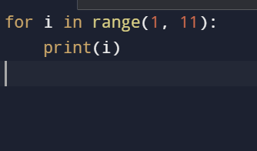

**OUTPUT**

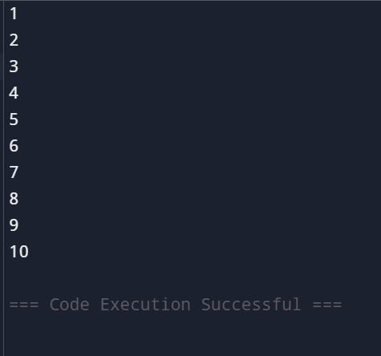

**TASK:2**

**Intermediate Task** (Print numbers from 10 down to 1 using a while loop)

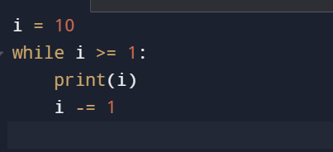

**OUTPUT**

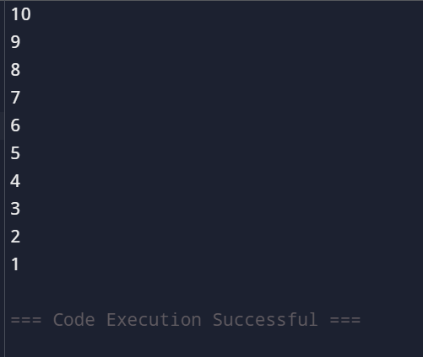

**TASK:3**

**Advanced Task (Count the number of vowels in a string using a for loop)**

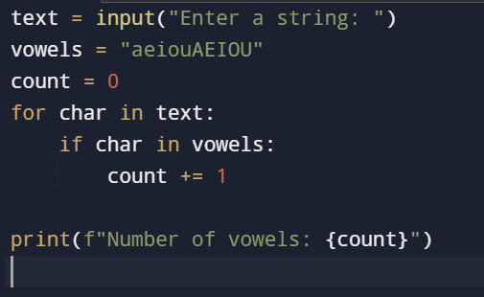

**OUTPUT**

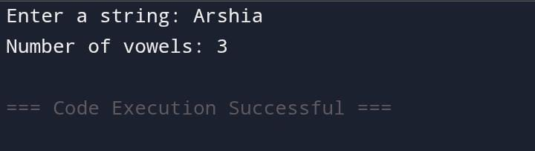

**TASK:4**

**Challenge Task (Print the Fibonacci series up to n terms using a while loop)**

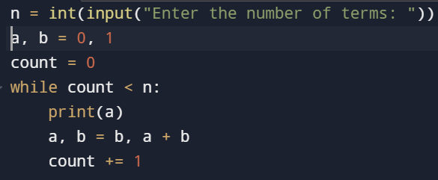

**output**

